What are CSS Breakpoints and Media Query Breakpoints
Shreya Bose, Technical Content Writer at BrowserStack - May 30, 2022

Table of Contents
- What are CSS breakpoints?
- How to set CSS breakpoints for Responsive Design
  - 1. CSS Breakpoints based on device
  - 2. CSS Breakpoints based on content
- Using min-width and max-width for CSS breakpoints
- The Media Query Breakpoints to be Used

What are CSS breakpoints?
Every website is accessed via devices with different screen sizes and resolutions. The software has to render perfectly across each screen size. Content or images cannot be distorted, cut out, or obscured.
To allow this, developers have to use CSS breakpoints. These are points defined in the code. Website content responds to these points and adjusts itself to the screen size to display the accurate layout.
Since CSS breakpoints for responsive design are implemented with media queries, they are also sometimes termed media query breakpoints.
With CSS breakpoints in place, the website content will align itself with screen size and displays itself in a way that pleases the eye and facilitates visual consumption.
Also Read: Breakpoints for Responsive Web Design
For example, when the website of The New Yorker is viewed on a regular desktop screen, the user sees the whole navigation menu across the top of the page. However, if it is viewed on an iPhone X, the smaller screen size will cause the navigation bar to appear on the top left of the screen as a hamburger menu.
Desktop View

Mobile View
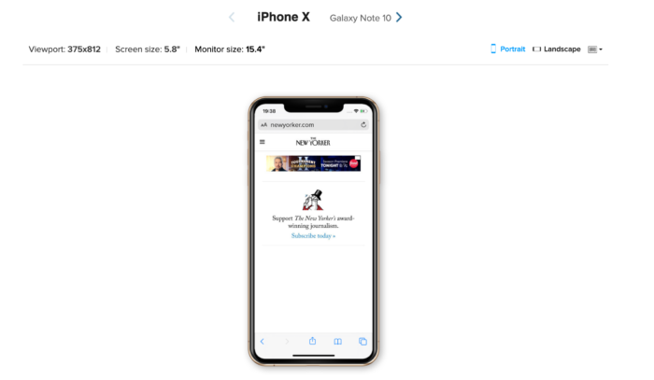
See for yourself on BrowserStack’s Responsive Design Checker.
Essentially, media query breakpoints are pixel values that a developer/designer can define in CSS. When a responsive website reaches those pixel values, a transformation (such as the one detailed above) occurs so that the website offers an optimal user experience.
Read More: How to Perform Responsive Testing for a Locally Hosted Website

How to set CSS breakpoints for Responsive Design
There are two main approaches to follow when setting CSS breakpoints for responsive design:

1. CSS Breakpoints based on device
With the current state of device fragmentation, determining breakpoints based on the device can be challenging. New devices are released in the market with increasing frequency, and keeping up with them generally requires significant effort.
Once a new device with a new screen resolution is released, developers will have to return to the CSS and add a new breakpoint. Imagine doing this every time a device is up for sale.
Even so, to cover all bases, one can at least set breakpoints based on the most popular devices used to access a website. Use Google Analytics for this purpose. Simply follow the path below:
Audience > Technology > Browser & OS > Screen Resolution
- Set breakpoints for the 10 device screen resolutions the website is accessed from.
Additionally, use a mobile-first design approach when working on the website layout. Design the site for mobile devices first, as approximately 50% of overall web traffic comes from mobile devices.
Read More: Mobile First Design: What It Is and How to Implement It
One could also set breakpoints for common device groups instead of specific devices:
/* Extra small devices (phones, 600px and down) */
@media only screen and (max-width: 600px) {...}
/* Small devices (portrait tablets and large phones, 600px and up) */
@media only screen and (min-width: 600px) {...}
/* Medium devices (landscape tablets, 768px and up) */
@media only screen and (min-width: 768px) {...}
/* Large devices (laptops/desktops, 992px and up) */
@media only screen and (min-width: 992px) {...}
/* Extra large devices (large laptops and desktops, 1200px and up) */
@media only screen and (min-width: 1200px) {...}
Source

2. CSS Breakpoints based on content
This is an easier approach that covers more ground. In this case, breakpoints are set based on website content. At every juncture in which the content needs a change in layout, a breakpoint is added. This makes media queries easier to code and manage.
A good rule to follow in this regard is to add a breakpoint when the content looks misaligned.
Visualize a paragraph of text. As the screen gets wider, it starts to become distorted, thus hindering readability. Adding a breakpoint here would prevent this from happening. The point of adding any breakpoint is to make content easy to read. This applies to both increasing and decreasing screen width. Whenever the content becomes harder to read because of changing screen size, add a breakpoint.
Let’s look at some examples:
CSS kicks in when the device width is 768px and above
@media only screen (min-width: 768px){
...
}
CSS kicks in within the limits : 768px to 959px
@media only screen and (min-width: 768px) and (max-width: 959px){
...
}
Read More: CSS Techniques for Improved Cross Browser Compatibility

Using min-width and max-width for CSS breakpoints
Setting breakpoints is easy with the min-width and max-width properties.
A couple of best practices are:
- When designing with the mobile-first approach (mentioned above), start with setting min-width breakpoints. The default styles should be for smaller device screens. Then, add and adjust for larger screens.
- Conversely, when designing for larger devices, set default CSS for them, and realign for smaller screens with the max-width property.
Confused? Perform a quick check of your website across real devices. Try now.

The Media Query Breakpoints to be Used
Obviously, it’s easier to go into website development knowing which CSS media breakpoints to use. The approaches outlined above require some research (with regard to popular devices and the nature of the content), but there are some CSS media breakpoints that are likely to fit most websites.
To start with, study popular frameworks such as Bootstrap, Foundation, and Bulma.
- Bootstrap: 576px, 768px, 992px, and 1200px
- Foundation: 40em and 64em
- Bulma: 768px, 769px, 1024px, 1216px, and 1408px
These frameworks facilitate mobile-first design, which is an industry best practice at this point in time. Therefore, using these breakpoints will offer more effective levels of website responsiveness.
Secondly, use breakpoints for the most commonly used device resolutions used across mobile, desktop, and tablet. These would be:
- 1920×1080 (8.89%)
- 1366×768 (8.44%)
- 360×640 (7.28%)
- 414×896 (4.58%)
- 1536×864 (3.88%)
- 375×667 (3.75%)
Also Read: What is the ideal screen size for responsive design?
Obviously, identifying and using CSS breakpoints for responsive design and media queries for all devices is not humanly possible. The best option is to deploy CSS media queries and breakpoints that fit the device preferences of the target audience. Additionally, keeping the content adjustable and adaptable to change would also help to accomplish more in the long-term with reasonable levels of effort.
Once a website has been designed and breakpoints incorporated, remember to test them on real devices to check their responsiveness. Depending on the number of screen sizes in question, checking responsive design is easiest when using a real device cloud.
BrowserStack offers 3000+ real browsers and devices for instant, on-demand cross browser testing on the cloud. Simply sign up for free, choose from among the latest devices, navigate to the relevant website, and start verifying its responsive design.
https://www.browserstack.com/guide/what-are-css-and-media-query-breakpoints

